**Primary Care Occupational Therapy Service**

The Primary Care Occupational Therapy service is based in GP surgeries across Lanarkshire. The information below will help you to identify if an assessment from a member of our Primary Care Occupational Therapy team might be helpful.

**What is Occupational Therapy (OT)?**

Primary Care Occupational Therapists (OTs) help people who have noticed that the everyday activities (occupations) that they need or want to do are starting to become more difficult.

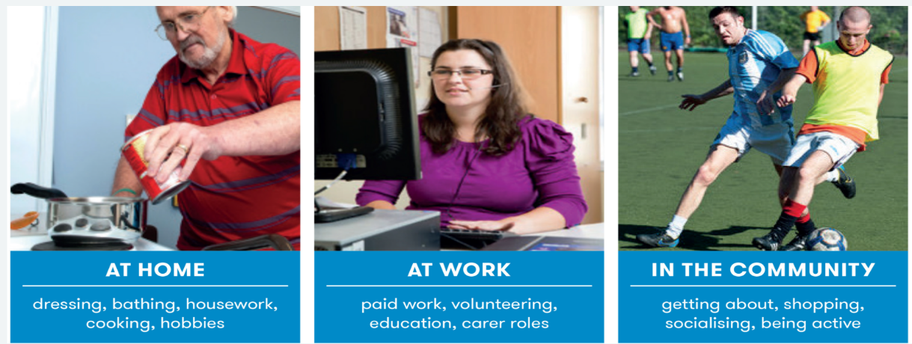

*These difficulties may be due to recent changes in your health, such as:*

Anxiety Falls or fear of falling Pain

Low mood Work-life balance Stress

Frailty Memory issues Fatigue

**How could the Primary Care Occupational Therapy service help me?**

When someone experiences a new health concern or disability, we know that early support to develop new ways of coping is important.

We will give you time to talk about the difficulties you are experiencing with everyday activities and set realistic goals together.

Working together, we can offer practical support, education and advice to help you manage your health and be able to do the activities that you need or want to do. This could include:

* Learning skills to help you live well with pain or fatigue-related conditions
* Developing practical coping strategies to help you manage stress, anxiety and low mood
* Supporting you to remain at work, return to work or improve your work-life balance
* Helping you to age well
* Offering advice about aids and equipment that make life easier

**How do I access Primary Care Occupational Therapy?**

You can self-refer to our service if

* You are registered with a Lanarkshire GP practice
* You are aged 16 or over and not in school
* You have recently noticed a change in your ability to carry out your usual roles and activities
* You are not already receiving Occupational Therapy from another service within the community. This includes services such as Social Work, Community Mental Health teams or Community Rehab teams.

There are 2 ways you can access the service:

1. Telephone our hub on 01698 755175 and speak to one of our admin staff or leave a message with your contact details.
2. Pick up a leaflet from your GP surgery, fill in the tear off slip and hand it in to the receptionist who will email it to us

**What should I expect?**

* Once we receive your referral, an occupational therapist will telephone you to find out if Primary Care OT is the right service for you. We may direct you to another service if this would best meet your needs.
* If we can meet your needs, we will arrange a longer appointment to get to know you better and find out what matters to you.
* We will discuss your health, the difficulties you are experiencing, your routine, roles, interests and goals. We may also use formal assessments to help us plan your treatment programme.
* Your OT appointments may take place at your GP surgery, over the phone, via a video call or in your own home.

For more information, scan the QR code to watch an animation.

